**RDBMS LAB ASSIGNMENT – 4**

**Group 6**

**Group Members-**

Aqtar Parveez(18BCS010)

Nisheer V (18BCS061)

R Dhanush Kumar (18BCS071)

R Naveen Devang(18BCS072)

Raghu Prasad J N(18BCS073)

Vivek Suresh(18BCS111)

**Main Table:**

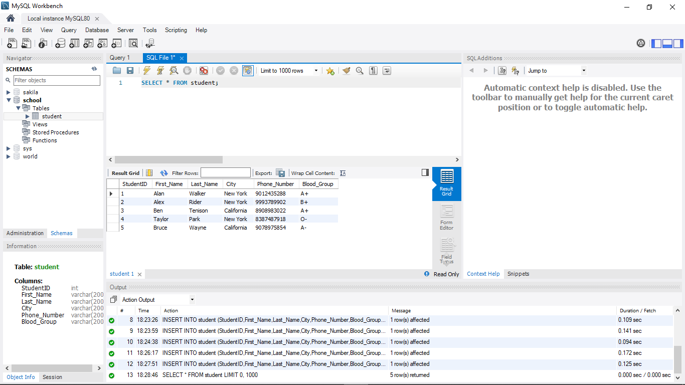

ORDER BY CLAUSE

ASCENDING ORDER

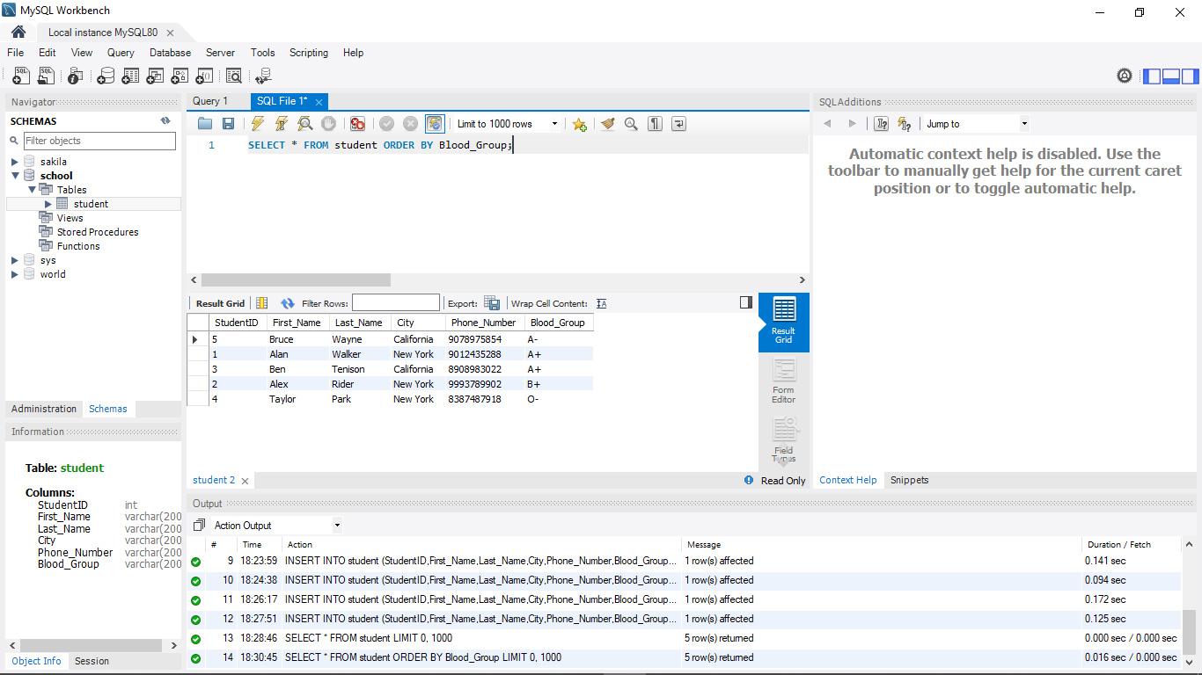

**DESCENDING ORDER**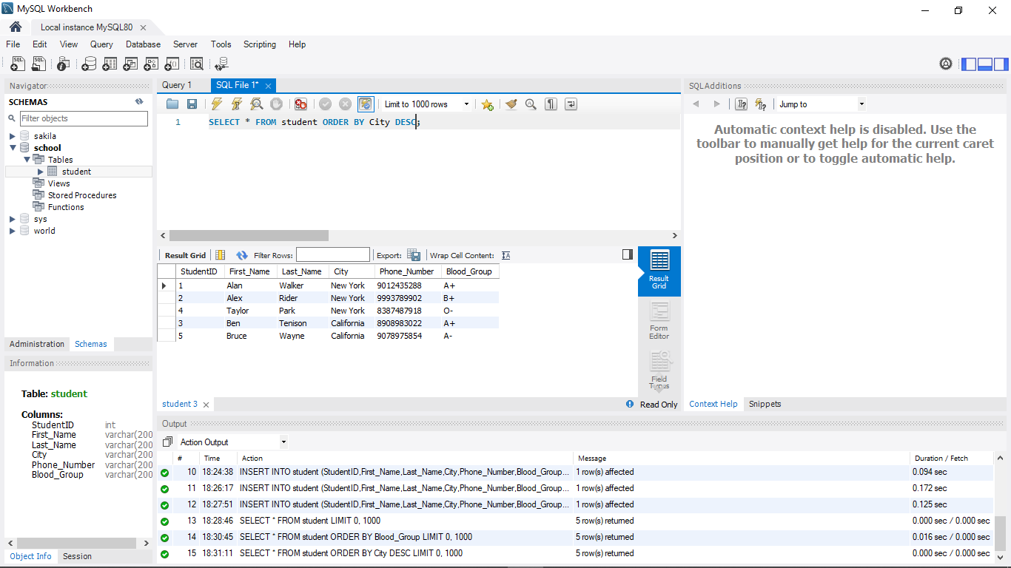

**GROUP BY**

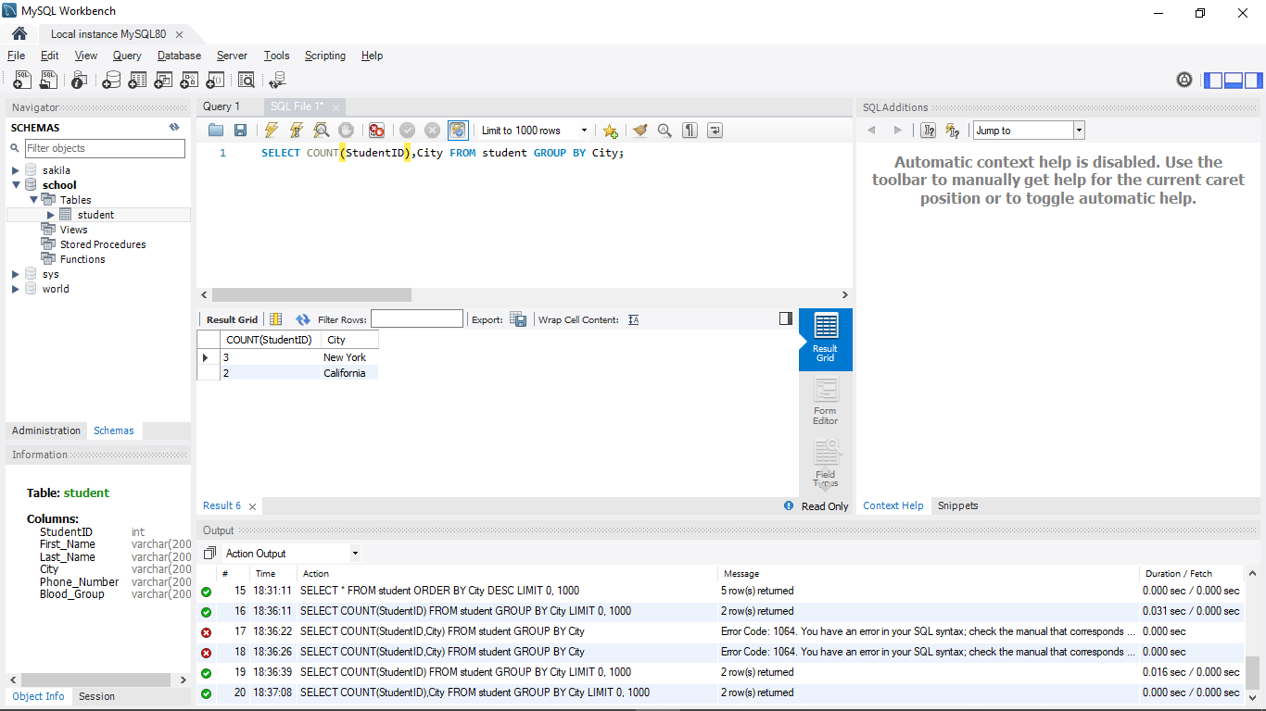

**HAVING**

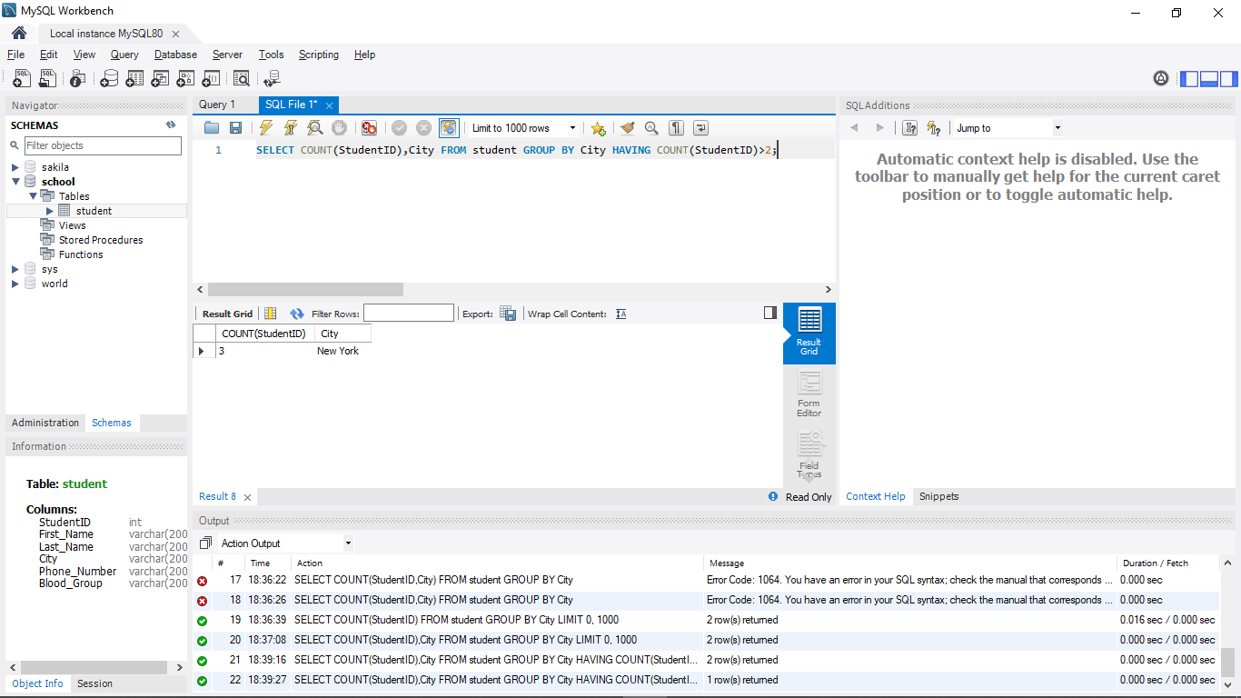

**AGGREGATE FUNCTIONS**

**MIN() FUNCTION**

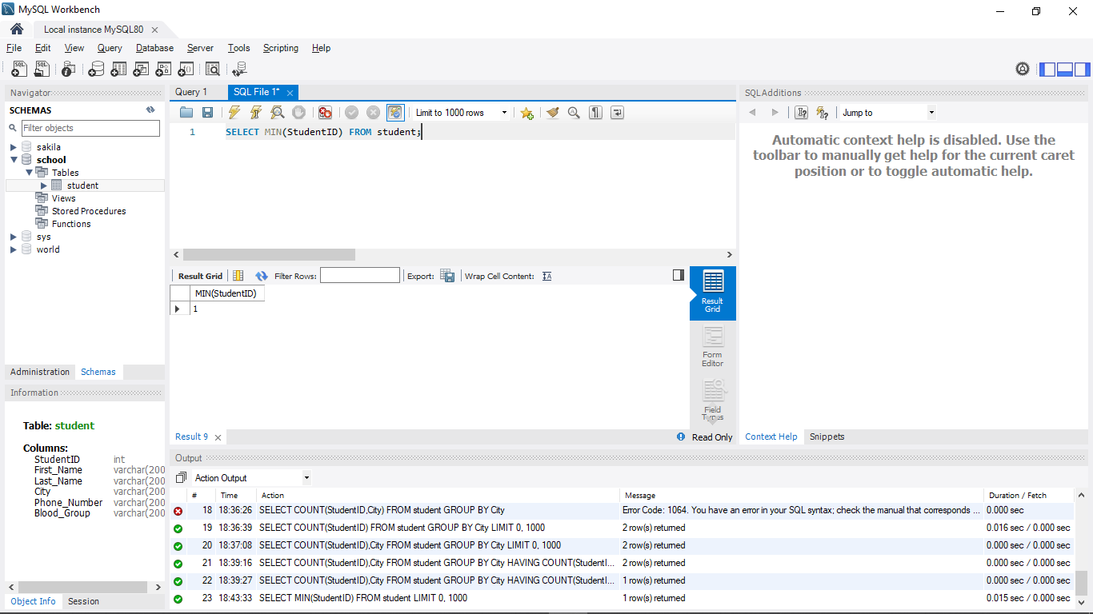

**MAX() FUNCTION**

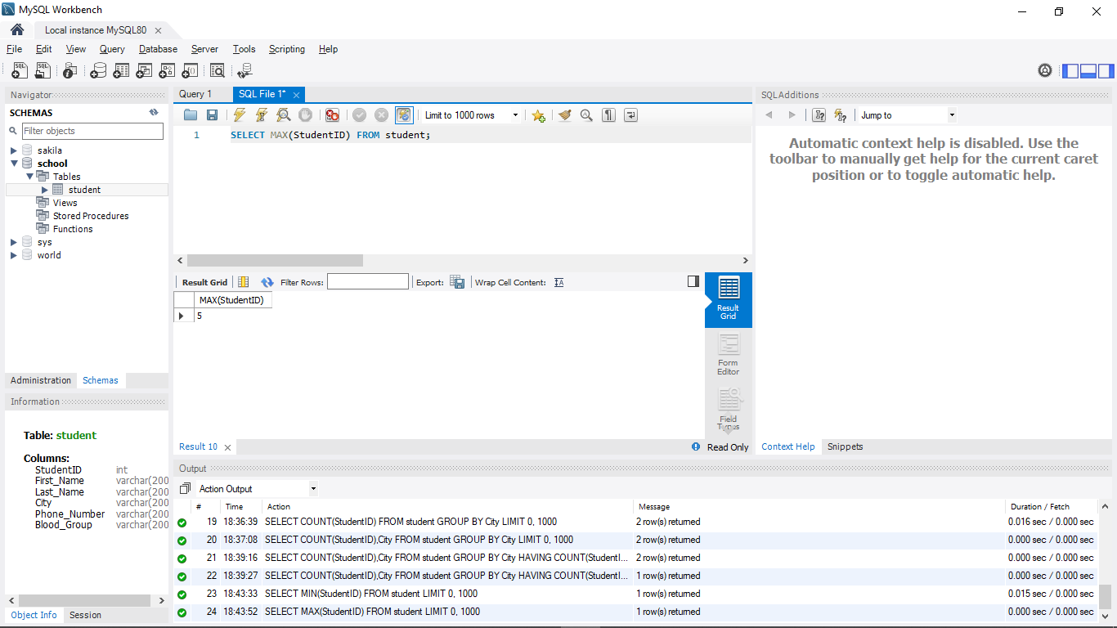

**COUNT() FUNCTION**

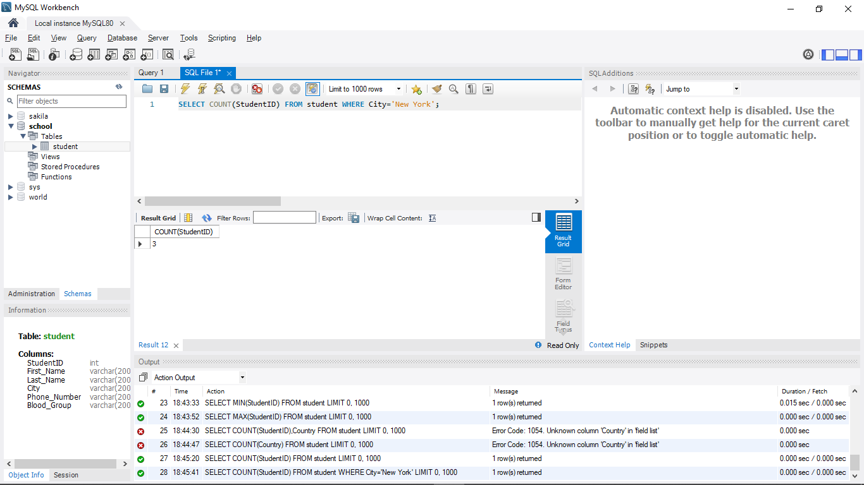

**AVG() FUNCTION**

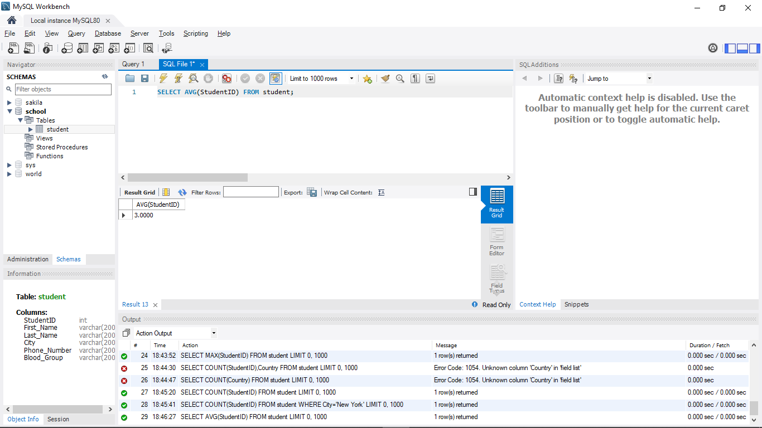

**SUM() FUNCTION**

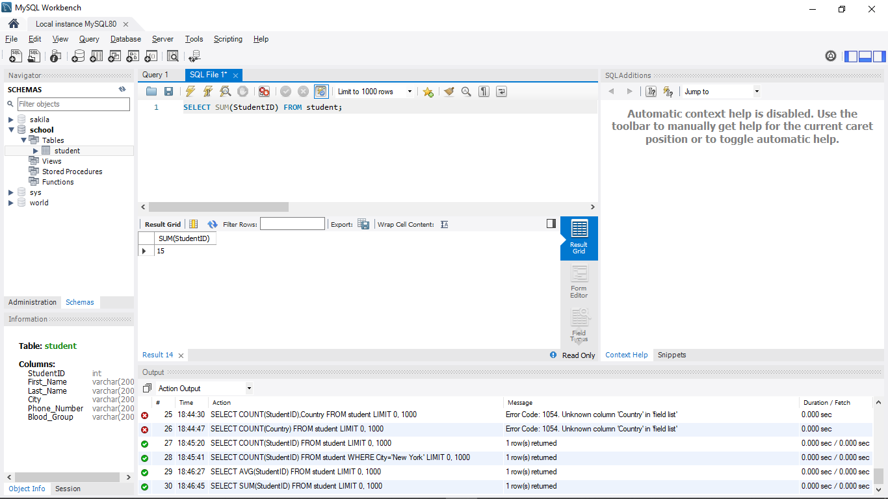

**LOGICAL OPERATORS ESPECIALLY WITH LIKE**

**‘A%’**

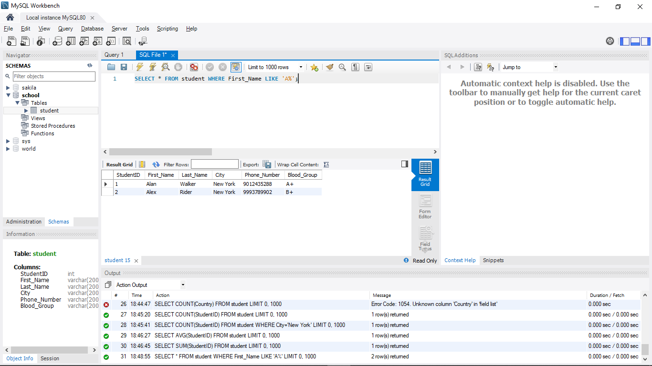

**‘%e’**

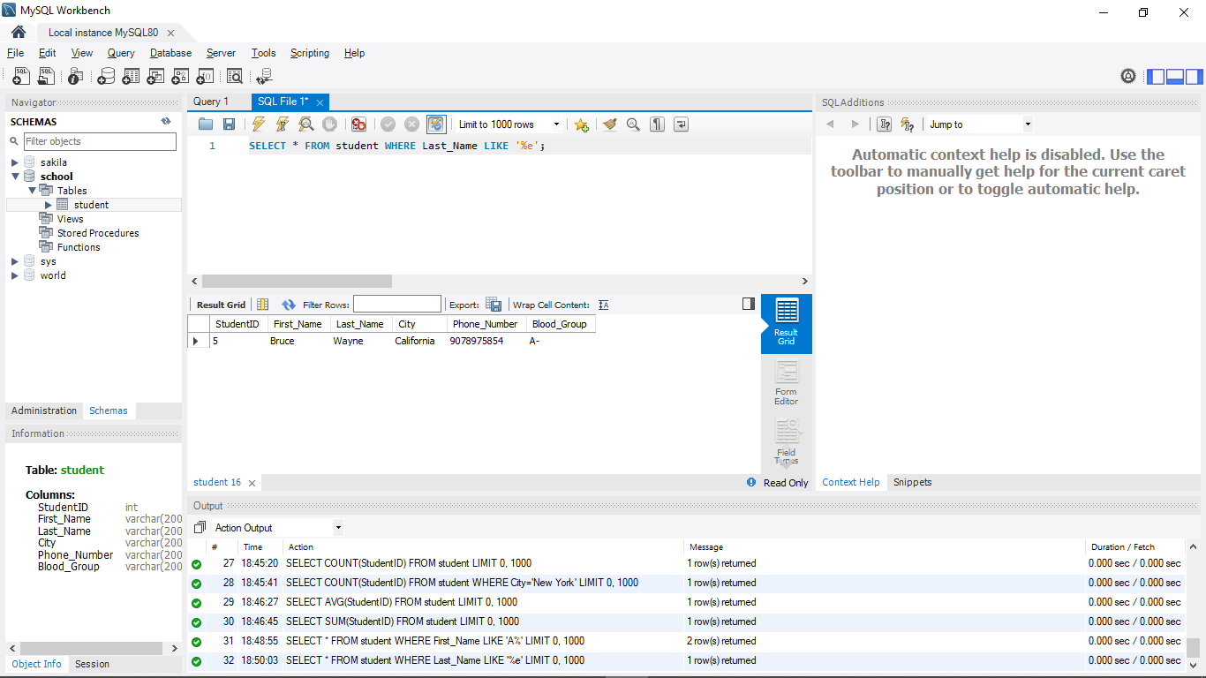

**‘_a%’**

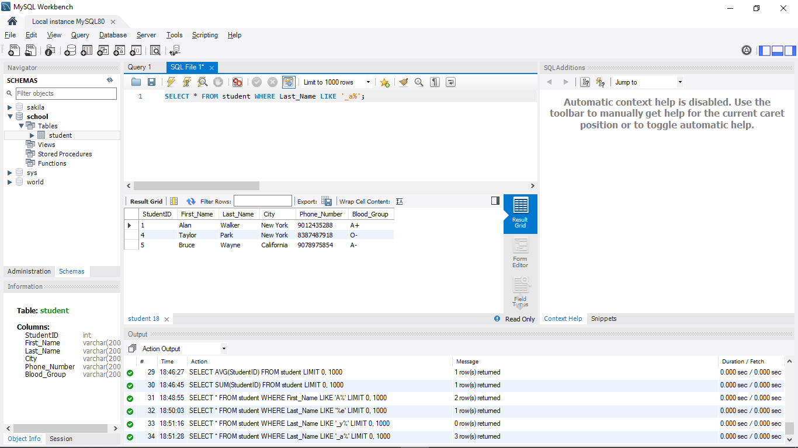

**‘B_’**

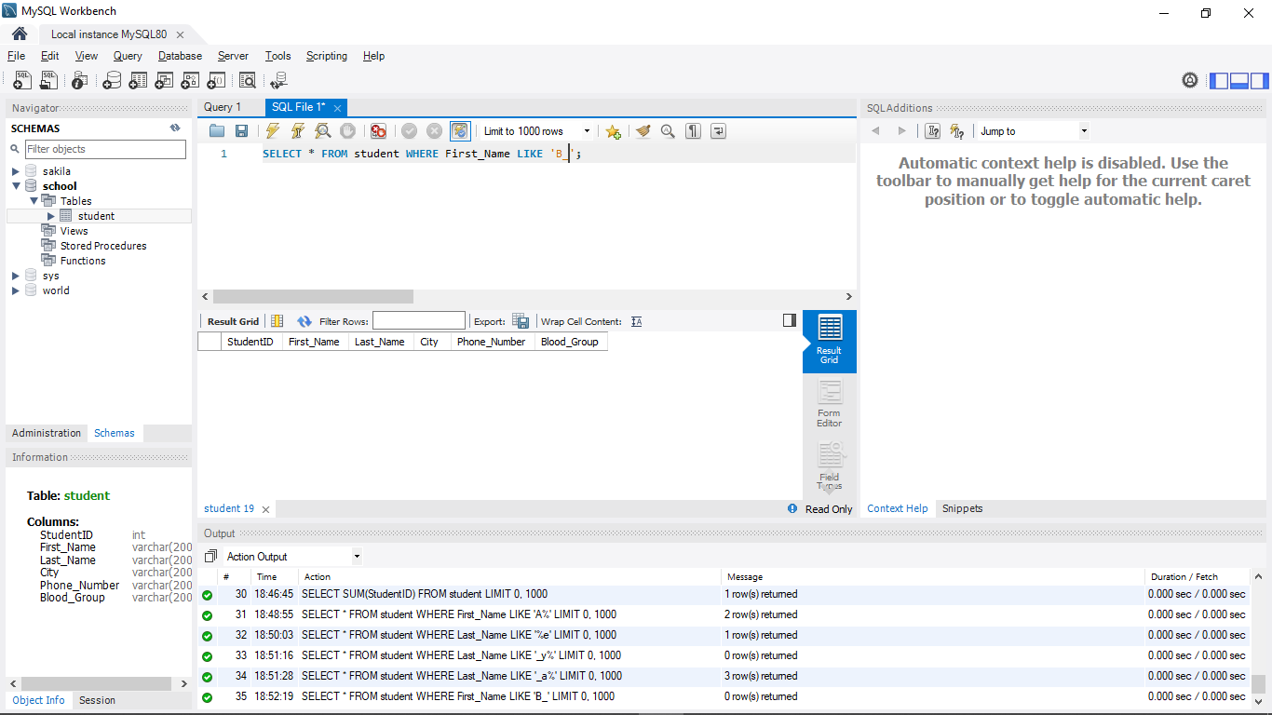

**‘B%a’**

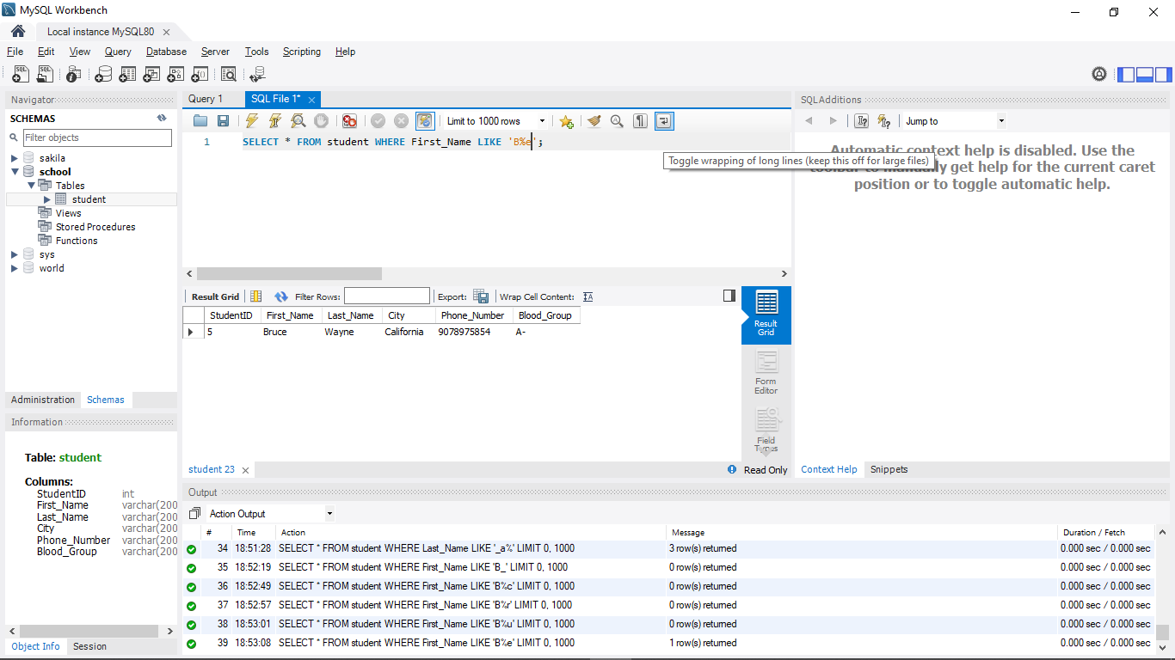

**AT LEAST 4 NESTED QUERIES SPECIFIC TO YOUR DATABASE,OUT OF WHICH AT LEAST 2 SHOULD HAVE MULTIPLE SUBQUERY**

